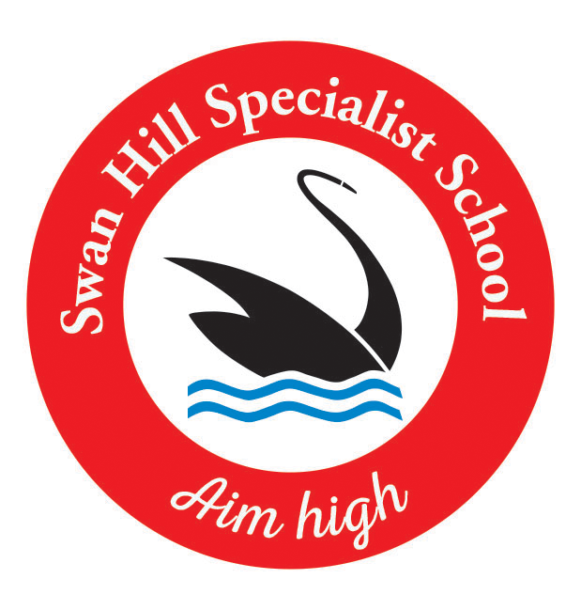

**Swan Hill Specialist School**

**Enrolment Policy**

**Help for non-English speakers**

If you need help to understand the information in this policy please contact Swan Hill Specialist School on 03 5032 3683 or swan.hill.ss@education.vic.gov.au.

# BACKGROUND

Swan Hill Specialist School provides educational programs for students who have an intellectual disability.

By law in Victoria all children from the age of 6 up until they turn 17 years must be enrolled at a registered school or registered for home schooling unless they have a reasonable excuse. School participation maximises life opportunities for children and young people by providing them with a comprehensive educational program and access to support networks. It also helps to develop important skills, knowledge and values that set them up for further learning and active participation in their local community.

Specialist schools, including Swan Hill Specialist School, have been established to cater for the specific educational needs of students with a disability or with additional needs. Under State and Federal discrimination law, specialist schools are permitted to set specific enrolment criteria and to not enrol students who do not meet these criteria.

## Purpose

The purpose of this policy is to specify the enrolment criteria for students seeking enrolment at Swan Hill Specialist School and the evidence required to support applications for enrolment.

It is intended to provide clarity for the local community on the enrolment criteria and ensure a smooth and supported transition for enrolling students.

## Scope

Enrolment at Swan Hill Specialist School is based on a student’s disability and associated educational needs. Subject to capacity, student intake may be at any stage of the year, providing the student is of school age and satisfies the eligibility criteria. All applications for enrolment at Swan Hill Specialist School require regional approval.

# ENROLMENT CRITERIA

The following enrolment criteria have been specified and approved by the Regional Director, North Western Victoria Region (as the Minister’s delegate) under section 2.2.16(b) of the *Education and Training Reform Act 2006* (Vic). A student’s enrolment will be reviewed periodically in line with their needs.

Students seeking to enrol must have:

*Intellectual Disability*

A diagnosis of Intellectual Disability from a registered psychologist evidenced by:

1. Sub-average general intellectual functioning which is demonstrated by a full-scale score of two standard deviations or more below the mean score on a standardised individual test of general intelligence, (for example a full scale score of 70 or below on one of the recommended standardised individual tests of intelligence);

and

1. Significant deficits in adaptive behaviour established by a composite score of two standard deviations or more below the mean on an approved standardised test of adaptive behaviour,(for example a Vineland Adaptive Behaviour Scales composite score of 70 or below);

and

1. A history and evidence of an ongoing problem with an expectation of continuation during the school years.

Applications from students who do not meet the above criteria will be considered on a case-by- case basis by the region, in consultation with the principal, in consideration of the student’s education and support needs. The Regional Director, North Western Victoria Region (or delegate) must approve enrolments for students who do not meet the eligibility criteria.

# PRIORITY ORDER OF PLACEMENT

In circumstances where the school may not have sufficient accommodation to be able to accept all applications from eligible students, the school will manage enrolment applications in accordance with the following priority order of placement:

1. Students with a sibling at the same permanent address who are attending the school at the same time.
2. Students who reside nearest to the school.

The school must ensure that all applicants eligible under the first criterion have been offered a place before moving to consideration of the second criterion.

## Verification of permanent address

When assessing enrolment applications under the priority order of placement, Swan Hill Specialist School may ask for supporting documentation to assist them in verifying a student’s permanent residence.

Swan Hill Specialist School may request original or certified copies of rental agreements, unconditional contracts of sale or other official documentation that demonstrates permanent residence.

Documents should show the same address and parent’s/carer’s name as recorded on the school enrolment application form.

The school may also make the following enquiries to verify the information provided:

1. checking the electoral roll at an Australian Electoral Commission office or the Victorian Electoral Commission head office
2. checking with a real estate agent to confirm a rental address
3. for a rental property which is a studio apartment or a one-bedroom unit, checking whether there are any regulations/codes limiting the occupancy of these apartments to one person per apartment.

The enrolment application may be unsuccessful if, after reasonable enquiries, the Principal is unable to verify that the evidence provided is genuine and valid. Applicants may then seek to appeal the decision according to the Appeal process outlined below.

## Enrolment on compassionate grounds

In exceptional circumstances, a student seeking enrolment at Swan Hill Specialist School who meets the enrolment criteria may be approved by the Regional Director North Western Victoria outside of the priority order of placement, based on compassionate grounds. This is an overarching consideration and does not form part of the priority order of placement. Further advice and support when considering applications on compassionate grounds is available on the [Policy and Advisory Library](https://www2.education.vic.gov.au/pal/enrolment/guidance/placement-policy#exceptional-circumstances-%E2%80%93-compassionate-grounds) and from regional staff.

# EVIDENCE AND SUPPORTING INFORMATION REQUIREMENTS

To support a student’s application for enrolment, the following evidence and supporting information should be provided:

*Intellectual Disability*

1. A signed psychologist’s report from within the last 24 months reporting the results of an IQ test and assessment of adaptive behaviour.

The Department provides assessment services to support specialist schools in determining whether the student meets their enrolment criteria. Department regional offices also play a role in supporting specialist schools with enrolment processes.

**NOTE: Enrolment applications may not be successful if the requested documentation is not provided or invalid.**

# APPEAL PROCESS

Parents/carers can appeal against the decision not to approve an enrolment by requesting a non-standard enrolment. This can occur in relation to enrolments at any age or year level. Further information on appeals can be found at [Enrolment: Enrolment in specialist schools | education.vic.gov.au](https://www2.education.vic.gov.au/pal/enrolment/guidance/enrolment-specialist-schools).

# COMMUNICATIONS

The Swan Hill Specialist School enrolment policy will be made available to the school community on the school’s website.

**POLICY REVIEW AND APPROVAL**

|  |  |
| --- | --- |
|  |  |
| Policy approved by | Principal 24/10/2023 |
| Next scheduled review date | 24/10/2027 |